**Percentile Summarisation**

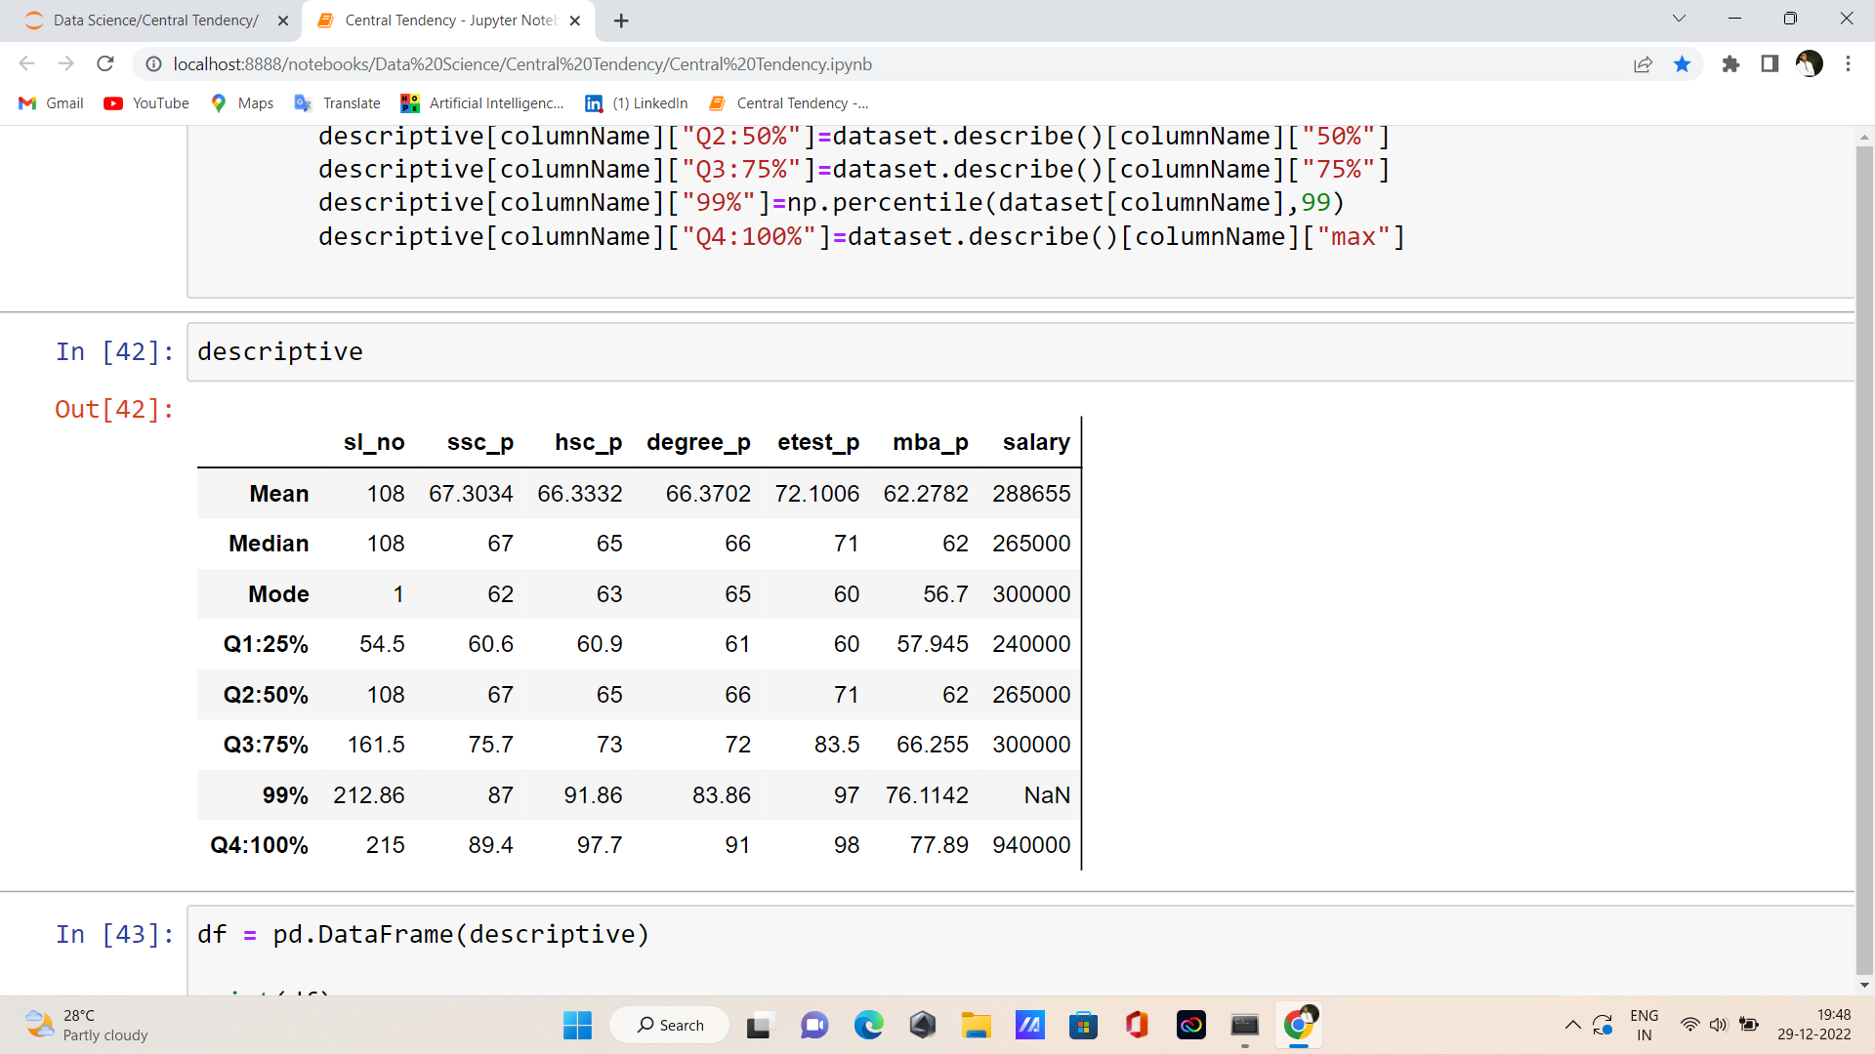

**The Summary:**

* + **SSC_P**
* The increment growth between Q1:25% to Q2:50% is **7%** in ssc_p.
* The increment growth between Q2:50% to Q3:75% is 8% in ssc_p
* The increment growth between Q3:75% to 99% **is 12%** in ssc_p
* The increment growth between 99% to Q4:100% **is 2%** in ssc_p.
  + HSC_P
* The increment growth between Q1:25% to Q2:50% is **5%** in hsc_p.
* The increment growth between Q2:50% to Q3:75% is **8%** in hsc_p
* The increment growth between Q3:75% to 99% is **18%** in hsc_p
* The increment growth between 99% to Q4:100% is **6%** in hsc_p.
* DEGREE_P
* The increment growth between Q1:25% to Q2:50% is **5%** in degree_p.
* The increment growth between Q2:50% to Q3:75% is **6%** in degree_p
* The increment growth between Q3:75% to 99% is **11%** in degree_p.
* The increment growth between 99% to Q4:100% is **8%** in degree_p.
* ETEST_P
* The increment growth between Q1:25% to Q2:50% is **11%** in etest_p.
* The increment growth between Q2:50% to Q3:75% is **12%** in etest_p
* The increment growth between Q3:75% to 99% is **14%** in etest_p.
* The increment growth between 99% to Q4:100% is **1%** in etest_p.
* MBA_P
* The increment growth between Q1:25% to Q2:50% is **5%** in mba_p.
* The increment growth between Q2:50% to Q3:75% is **4%** in mba_p
* The increment growth between Q3:75% to 99% is **10%** in mba_p.
* The increment growth between 99% to Q4:100% is **1%** in mba_p.

The Percentage Pass mark are in increment growth.

**Thank You**